Pivot Tables and Charts
- What is the purpose of a PivotTable in Excel?
- A PivotTable in Excel is used to summarize, analyse, and explore large amounts of data quickly and interactively without changing the original data.

- Create a PivotTable to show Total Sales by Region.

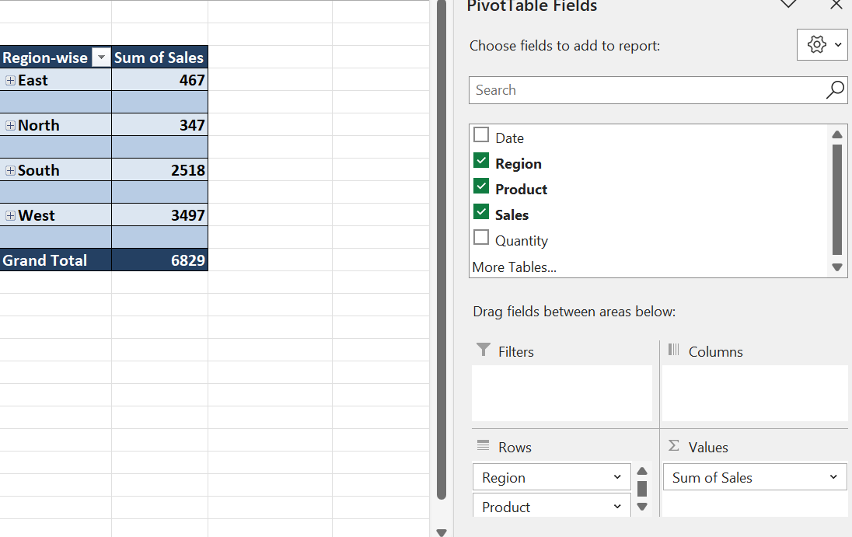

- Apply Conditional Formatting to highlight sales greater than 400.
- Select the Sales column from D2 to the last, then go to the home tab choose conditional formatting and select new rule then apply use a formula to determine which cells to format and enter formula- =D2>400 (make sure D2 is the first cell we choose), click format and choose color to highlight it and then OK and this will give the desired output as shown below-

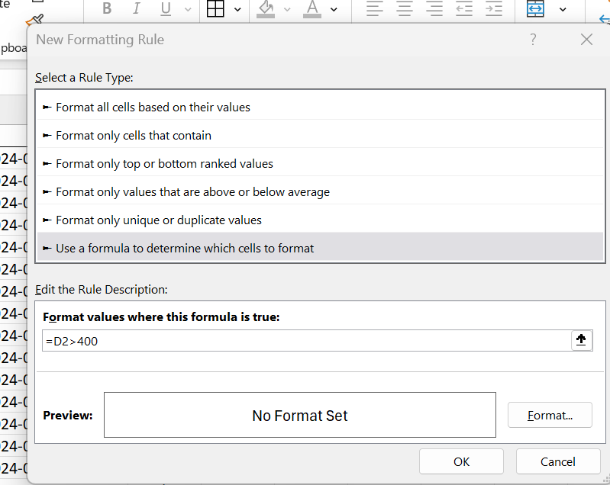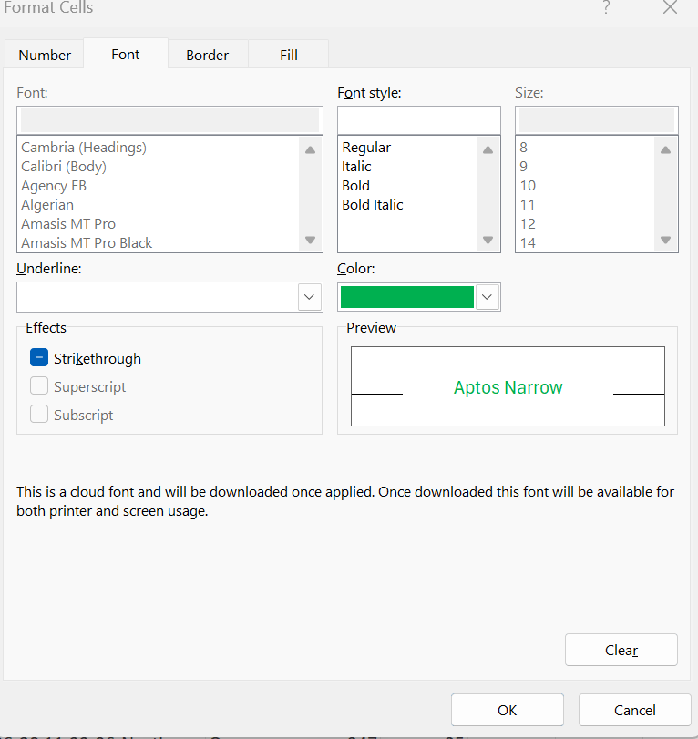
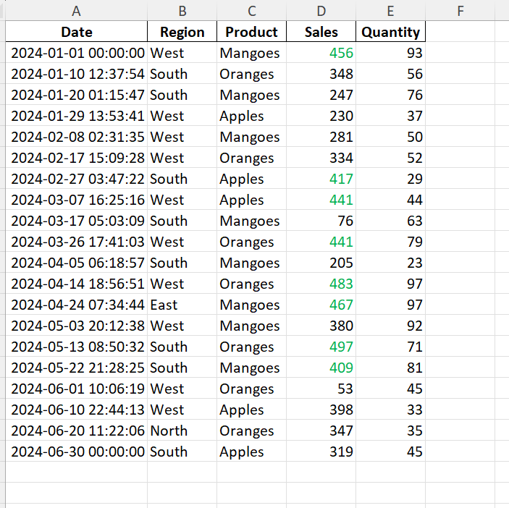

- Explain the difference between Sorting and Filtering with an example from this dataset.
- Sorting changes the order of rows based on a column, but keeps all records visible.
If we sort the number in sales column by the asceding order then data will be rearranged as shown below-

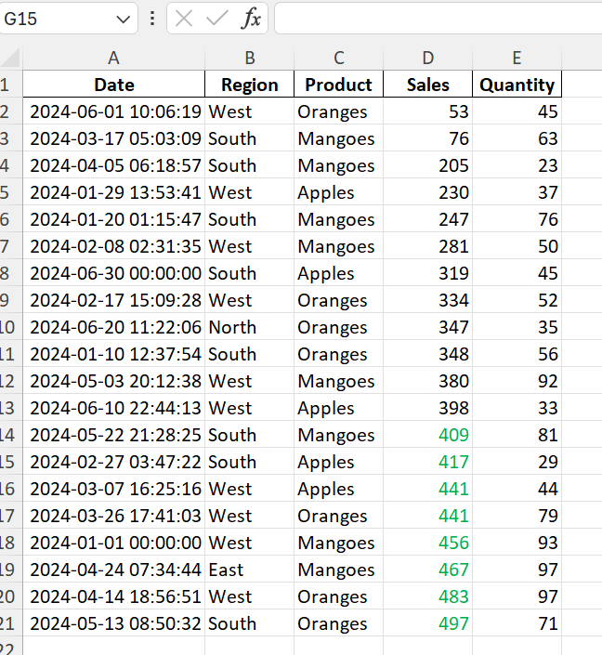

- Filtering displays only rows that meet a condition and hides the rest. If we apply filter with given condition sales>400, it will only show the rows that meets the rule-

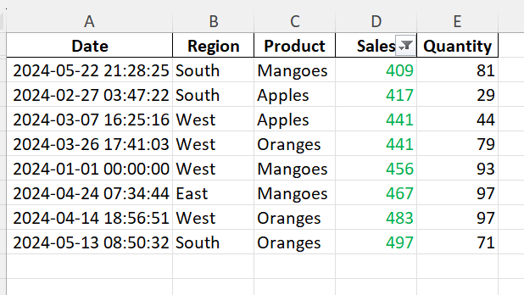

- Create a PivotChart showing Monthly Sales Trend.
- Select the data and insert Pivot Table with date in rows and Sales in values, then right click on any date and choose group option and it will show total sales per month and with help of that insert pivot chart accordingly.

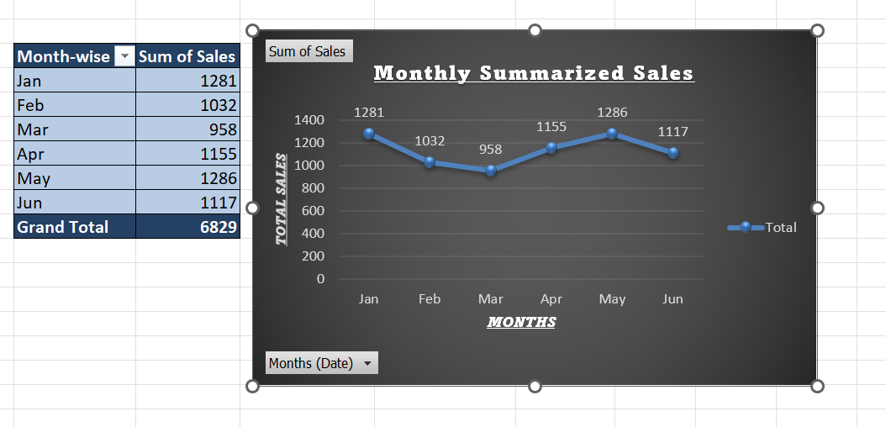

- Use a Slicer to filter data by Product and observe changes in sales.
- Select anywhere in the Pivot Table and go to the PivotTable Analyze and insert Slicer then check product and ok. The slicer will appear with Apples, Mangoes and Oranges choose Mangoes or any option and see how the Table and Chart changes.
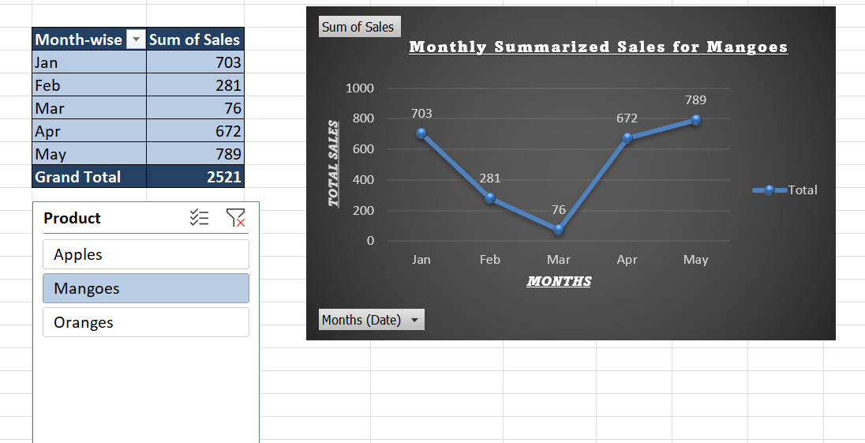
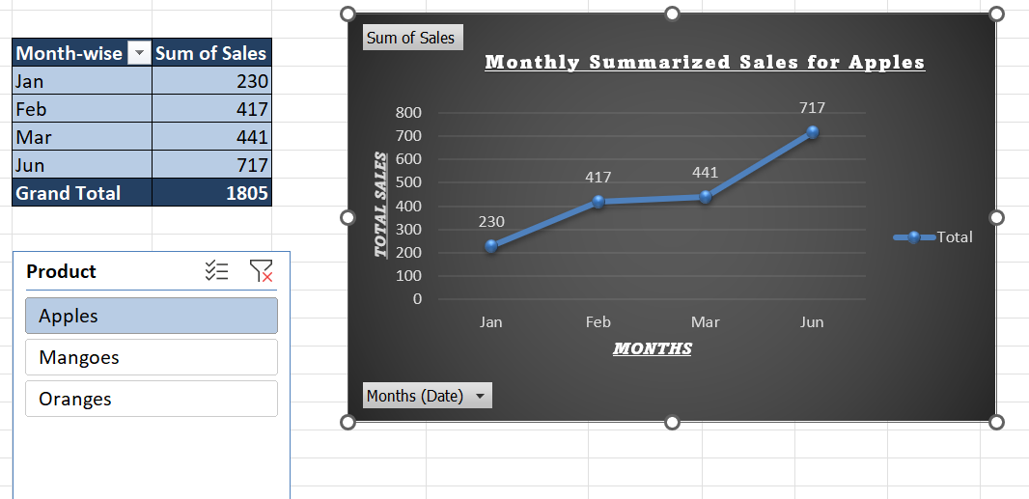

And then we can choose all products and clear filter icon and then it will show all products combined again.

- Why are Dashboards important for decision-making in business analysis?
- Dashboards are important for decision-making in business analysis because they turn raw data into clear, actionable insights that decision-makers can understand quickly.

- Create a Dashboard that includes:
- Select all data and insert PivotTable, drag region in Rows and sales in Values.
Select the PivotTable and go to the PivotTable Analyze choose Pivot chart and select column chart, change the title and add data labels.

- Add a slicer from PivotTable Analyze and choose products, click on any of the products(Apples, Mangoes, Oranges) and all connected PivotTables and Charts update instantly.

- Insert a new PivotTable, drag date in Rows and sales in Values
Right-click on any date and select group as in months.
Select the PivotTable and go to the PivotTable Analyze choose Pivot chart and select line chart, change the title and add data labels.

- Create a new worksheet, name it as Dashboard and put all the PivotTable and Pivot chart on it, remove the gridlines for better clarity.

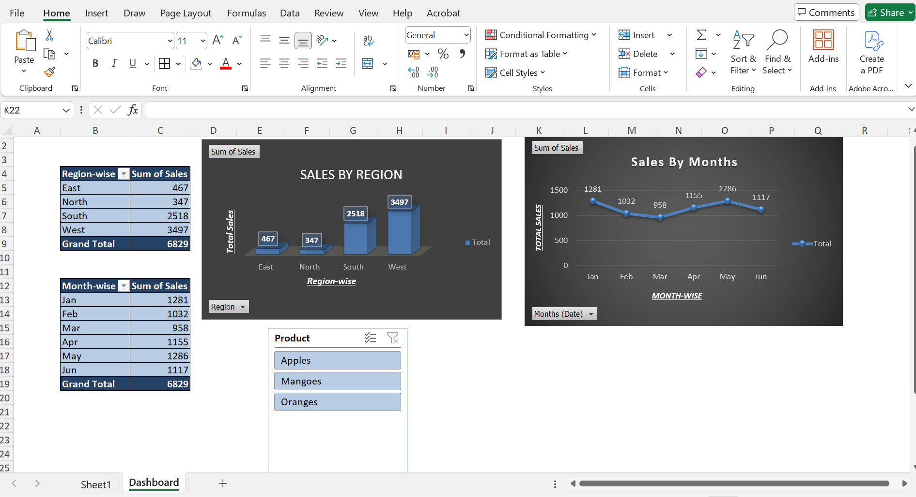

- Group dates in the PivotTable into Months and calculate the average sales per month.
- Select the data and insert a PivotTable, drag date in Rows and sales in Values. Right-click on any date and select group as in months. Click the drop-down arrow on Sum of Sales in the Values area, choose the value field setting and select Average
Now the PivotTable shows months and average value in sales.

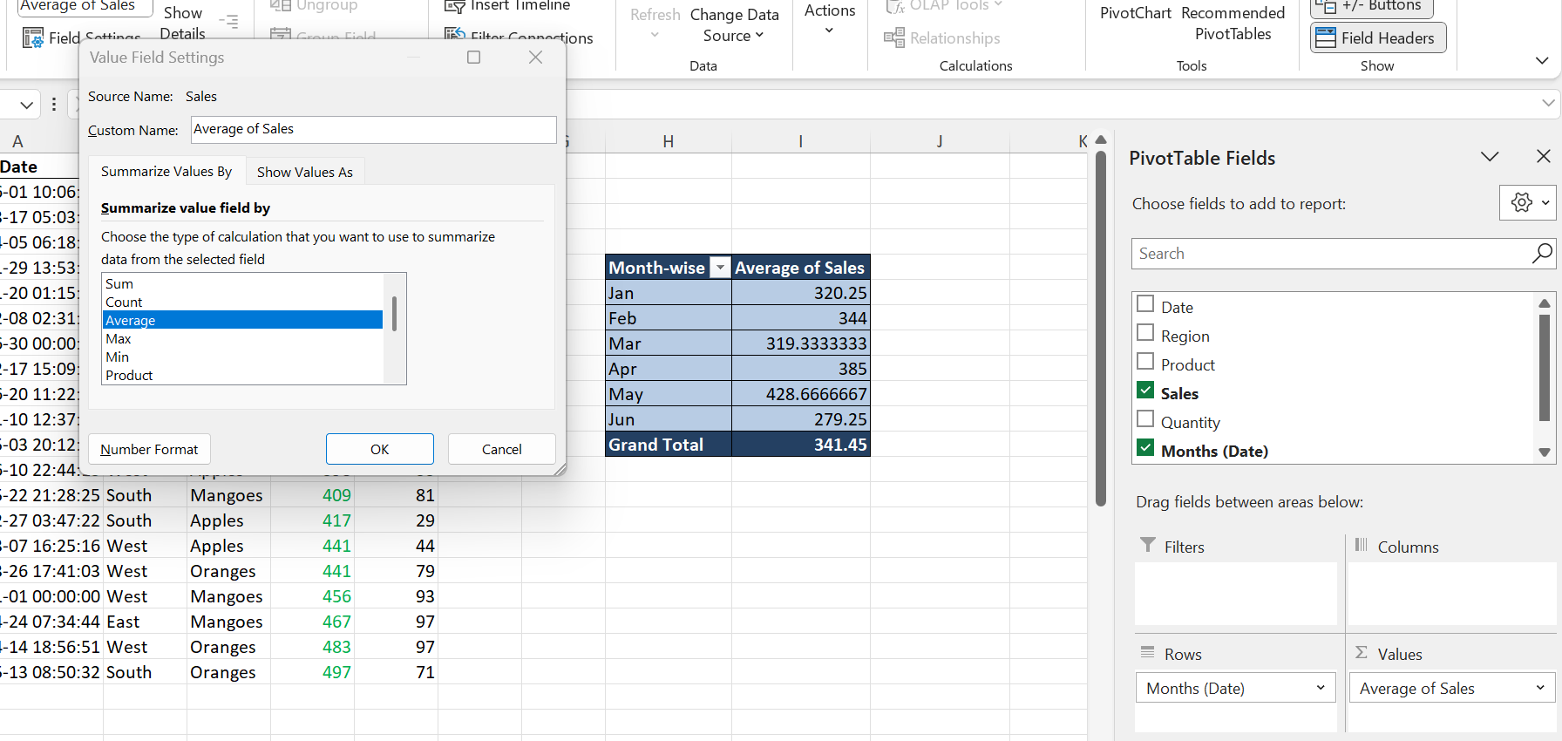

- Combine Apples and Oranges into one group called Fruits and compare its sales with other products.
- Select the data and insert a PivotTable, drag Products in Rows and sales in Values. Select Apples and Oranges both, right-click on any and choose group then excel creates Group1 by default rename as Fruits. Now PivotTable will show as Fruits and Mangoes, create a Pivot Chart to visually compare sales.

